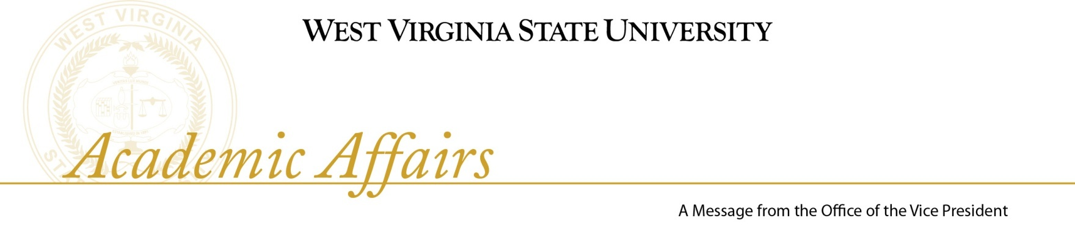

Friday, February 12, 2010

ANNOUNCEMENTS

- Sunday, February 14, 2010 - 6:00 PM - Wilson University Union
Candlelight Vigil and narration of the history of the Cabell love story. Mrs. Carter will be the speaker.

- Monday, February 15, 2010 - 1:00 PM - P. A. Williams Auditorium, Ferrell Hall Memorial Service for Dr. Andrew N. Aheart - Dr. Aheart was the Chair of the Mathematics Department and Chaired the Division of Natural Sciences and Mathematics. He retired with 60 years of service.

- Tuesday, February 16, 2010 - 12:30 PM -135 Wilson Student Union
Professional Studies Convocation with two panel discussions. One is entitled “Extending the Mission” which is open to the University community. The second is on Thursday, February 18th, entitled “Career Success Strategies”. It consists of three concurrent sessions for students in the College of Professional Studies. The sessions are open to all students, but is pre-registration is encouraged (Wallace 521). This convocation is being sponsored jointly by the College of Professional Studies and the Office of Career Services.

- Thursday, February 18, 2010 - 11:00 AM - P. A. Williams Auditorium, Ferrell Hall
Black History Convocation - The speaker will be Mr. Lou Myers. Mr. Myers is a 1962 graduate of West Virginia State College, with a B.A. degree in Sociology. He has received several awards for his acting and directing.

- Friday, February 19, 2010 - 8:30 - 11:30 AM
Higher Education Day - West Virginia State Capitol

- Wednesday, February 24, 2010 - 9:30 AM - 1:00 PM
West Virginia State University Day at the Legislature - West Virginia State Capitol, second floor - More than 25 tables will represent all areas of the WVSU experience. The Jazz Ensemble, Cheerleaders, and Student Government will participate.

