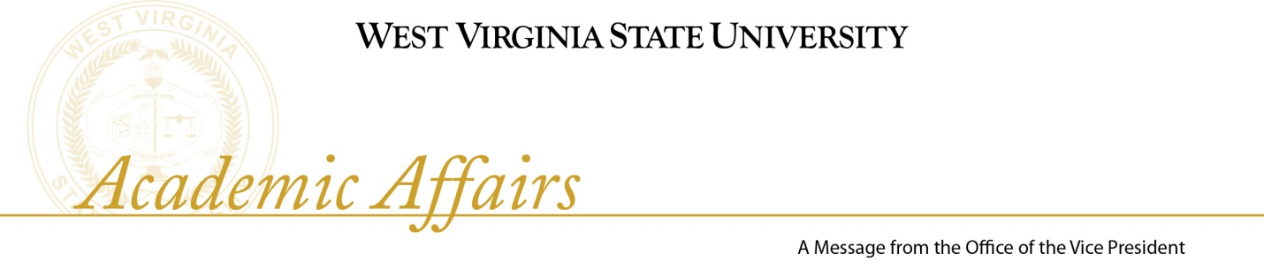
November 5, 2010

Deans Council weekly meetings focus on issues that impact the operation of the Academic Affairs area of the University. In a state-wide meeting of academic officers Chancellor Noland noted that a major thrust in higher education will be getting people back into college to finish, retaining those students who enter, and preparing students for jobs which require college graduates. E-portfolios were also discussed and the movement by nearly all institutions to this process; LiveText is an e-portfolio system that will become an integral part of our assessment data in our next North Central Higher Learning Commission accreditation process. HLC has historically conducted its accreditation process using the self-study; WVSU will be among the last schools under that system before they begin a transition to the new Pathways system. It will require a miniature self-study nearly every year and assessment data collected over several years to document our progress. The HLC is planning a data depository where we will deposit our information for HLC reviewers to see whenever they wish. Dr. Pelphrey will meet with Departments to assist them in designing their assessment system and collecting their data. We will discuss this widely with faculty over the next several months.

The former Information Skills requirement has been removed from the WVSU general education requirements effective for students entering under the 2010-2011 College Bulletins and University catalog. The specified skills have now been incorporated for all students into courses in general education and in their majors. Removal of this requirements does not reduce the number of hours required for graduation.

In an effort to facilitate accurate advising of transfer students, the Registrar has begun doing general education transcript evaluations as well as checking whether or not the prior institution is accredited and that the transfer hours are correct. It is envisioned that the Department Chair will evaluate courses for the major.

The summer school schedule for 2011 is in the process of being posted; students will be able to register for summer classes beginning November 15.

The Institutional Compact is complete and is posted on the WVSU website. An icon for the Year 1 and Year 2 Compact Reports is in the lower right quadrant on the homepage. The HEPC has asked for some additional information for the report and we are currently assembling it.

Academic Affairs Council met on October 21. Reports included that we have approximately 300 students enrolled in Early Enrollment courses (formerly known as Dual Credit) this semester. Orientation, Advising & Registration session for new students accepted for January will occur on Saturday, December 4. The information to register for the Orientation Session is on the WVSU website behind the New Student Advising & Registration icon. The Library is working with Better World Books to take the deselected books for resale or donation. Some of the profits generated from resale of the books will be contributed to the Books for Africa project.

Academic Leaders did not meet during October.

Outstanding Student Organizations the American Chemical Society (ACS) student chapter at WVSU has been selected by the American Chemical Society to receive the Commendable Chapter rating, which only 68 chapters in the nation received this rating. They were also one of 52 chapters in the nation to receive the Green Chemistry Award for its activities during the 2009-2010 academic year. They also wrote and received a nationally competitive community interaction grant sponsored by the ACS.

